**TEAM 7**

**AAKRITI, SWASTIKA, SURABHI, RITIKA**

**GAME 1: Underestimated patterns**

As the name suggests. It is a game about pattern building. There will be 5 pattern based questions. For every question there will be few test cases. The first person who passes all the test cases for a particular question gets a chance to deduct 2 marks of any one opponent. The questions we thought of, are given below. We can do further modifications to make it a bit more interesting. I have turned these questions into hurdles of a story. Plus, as the competition is a bit easy, only 1st n 2nd year students will be awarded the prizes.

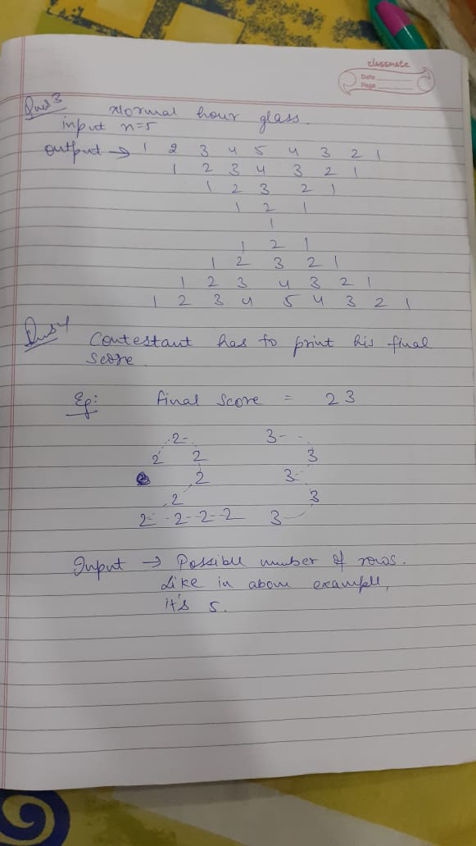 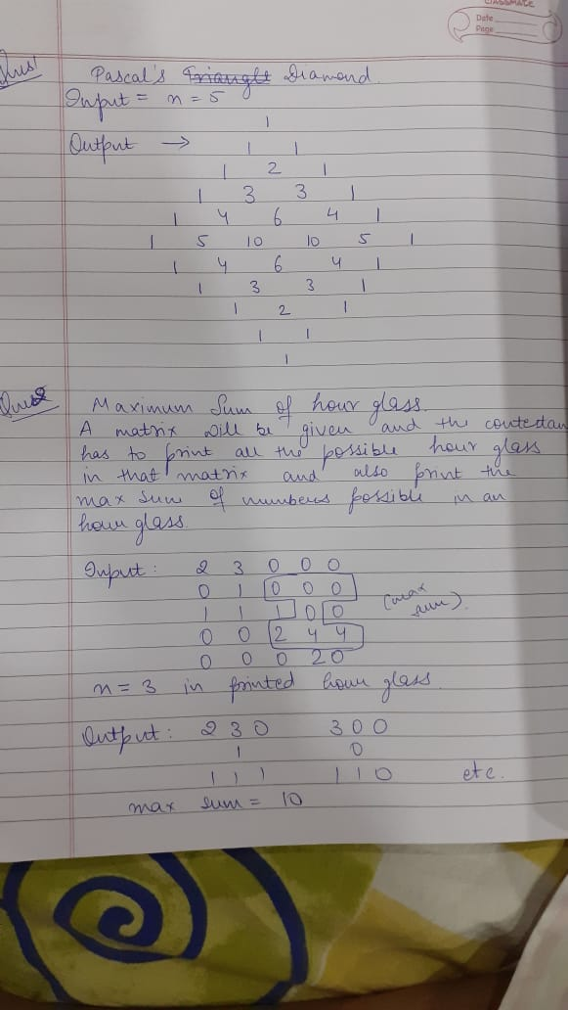

Q5. Drawing the wave pattern where the height and the number of the peaks will be the input for the question.

**GAME 2: Know the unknown**

**STAGE 1:** There will be 2 members in a team. They will be given a question to code in c++ or java. First member will code for first 10 min then the next member. Condition being the next person has to continue with the same code and with no discussion with the team mate. Those who qualify in this, go for the second stage!

**STAGE 2:** Either we will be developing our own language (and a compiler) or we will take a not so common language. For their understanding, they will be given a code, the input and the corresponding output to understand various syntax. Like what means what. Then they will be given 5 questions(2 easy, 2 medium and 1 hard difficulty level). And they have to code it in that same language.